Activity: • You have lot of builds happening that causes memory issues in the Jenkins server. Limit the number of builds to 1 and delete other builds. Also delete builds older than one day. • Steps: • Go to configure in PetClinicTest job. • Enable discard old builds in General tab. Give number of builds as two and delete builds older than one day.

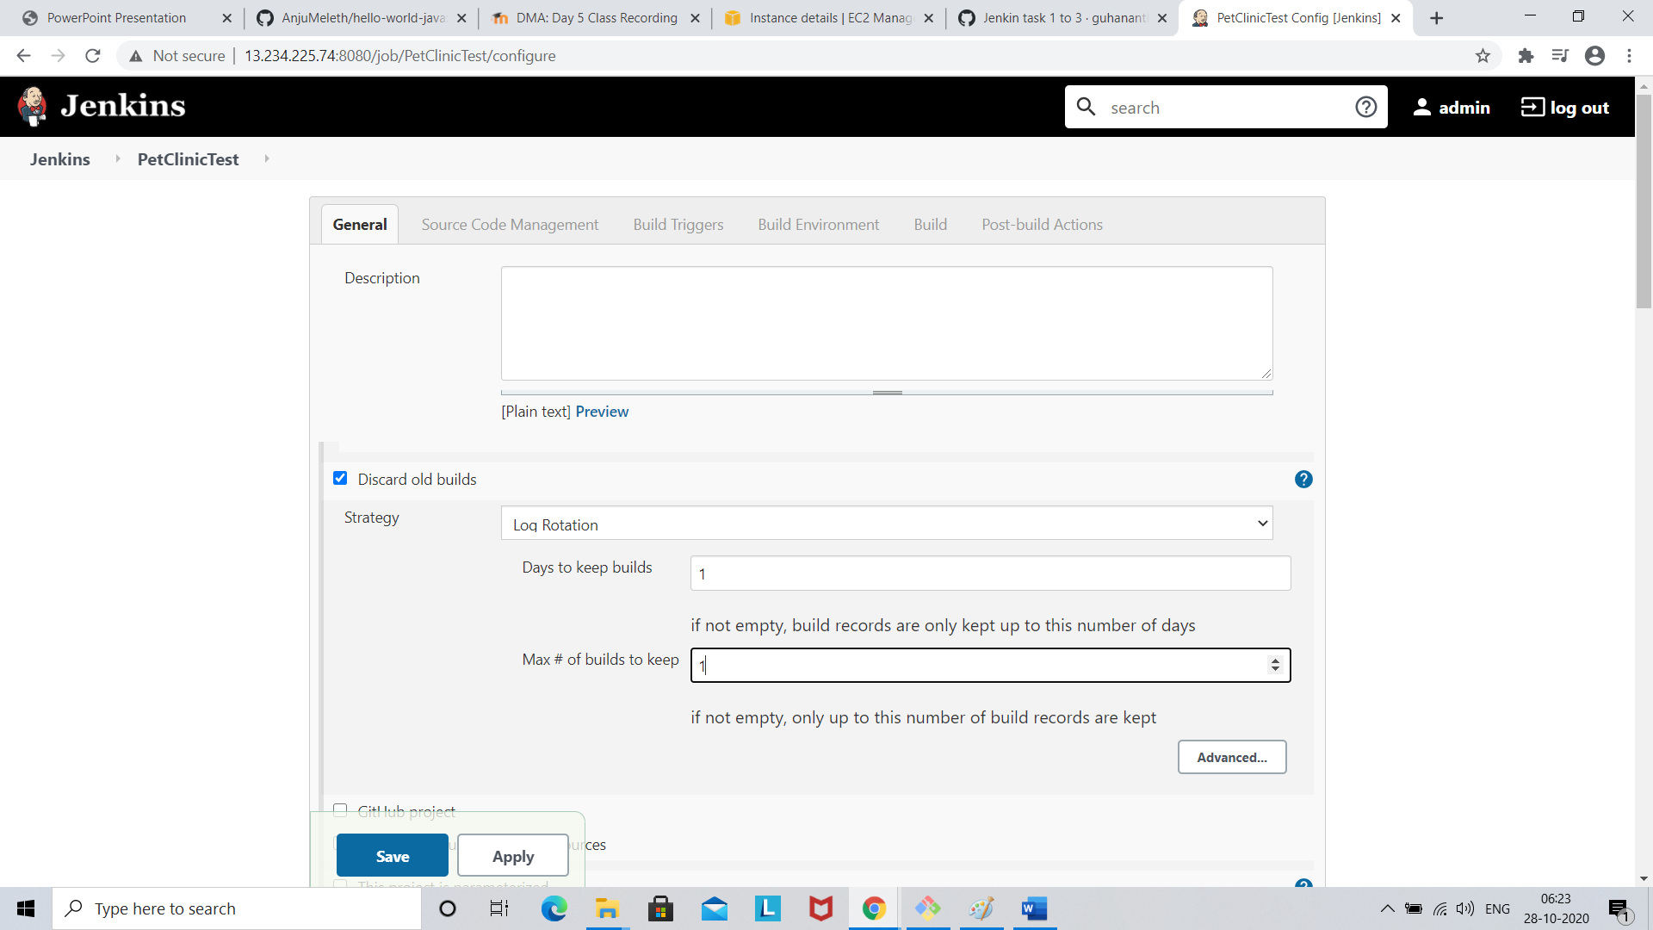

Click save

Build now

